Steps to Install kubelet, kubeadm, and kubectl
- Add Kubernetes Repository First, you need to add the Kubernetes package repository to your system.

sudo apt update && sudo apt install -y apt-transport-https curl
curl -s https://packages.cloud.google.com/apt/doc/apt-key.gpg | sudo apt-key add -
sudo bash -c 'cat <<EOF > /etc/apt/sources.list.d/kubernetes.list
deb https://apt.kubernetes.io/ kubernetes-xenial main
EOF'

Update Package Index After adding the Kubernetes repository, update your system's package index
sudo apt update

Install kubelet, kubeadm, kubectl Now, you can install the Kubernetes components: kubelet, kubeadm, and kubectl.
sudo apt install -y kubelet kubeadm kubectl

• kubelet: The primary node agent that runs on each machine in your cluster. It ensures that containers are running in pods.
• kubeadm: A tool for initializing and managing Kubernetes clusters.
• kubectl: The command-line tool for interacting with the Kubernetes API server.

Mark Packages to Prevent Auto-Upgrade To avoid the accidental upgrade of Kubernetes components, you should hold these packages at their current version.
sudo apt-mark hold kubelet kubeadm kubectl

sudo vim /usr/lib/systemd/system/kubelet.service.d/10-kubeadm.conf

add this
Environment="KUBELET_KUBECONFIG_ARGS=--kubeconfig=/etc/kubernetes/kubelet.conf"

sudo kubeadm init phase certs ca
sudo kubeadm init phase certs apiserver
sudo kubeadm init phase certs apiserver-kubelet-client

After generating the certificates, you should be able to run the kubeadm init phase kubeconfig kubelet command again to generate the kubelet configuration
sudo kubeadm init phase kubeconfig kubelet

ls /etc/kubernetes/
If you see the kubelet.conf file, you can proceed.

sudo systemctl enable kubelet
sudo systemctl start kubelet

kubectl version --client
kubeadm version
kubelet –version

Additional Configuration Steps (Optional)
- Disable Swap: Kubernetes requires swap to be disabled on all nodes. You can disable swap by running:
sudo swapoff -a

• To make this change permanent, comment out or remove the swap entry from /etc/fstab.
• Check Docker or Containerd: Ensure Docker or cri-dockerd (or another container runtime) is running, as Kubernetes depends on it for managing containers.

Next Steps (Setting Up Kubernetes Cluster)
Once you have kubelet, kubeadm, and kubectl installed, you can proceed with setting up your Kubernetes cluster using kubeadm.
- Initialize Kubernetes Master Node: On your master node, run:
sudo kubeadm init
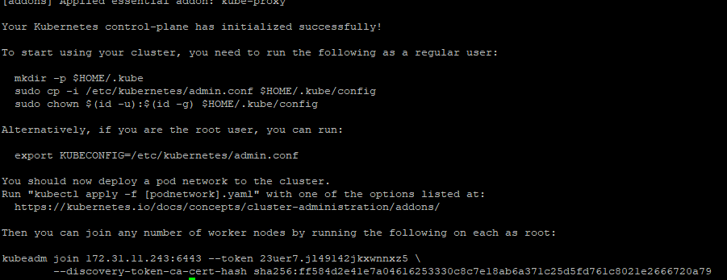

Set Up kubectl for User: After the initialization of the master node, you will be instructed to run the following to configure kubectl for your user:
mkdir -p $HOME/.kube
sudo cp -i /etc/kubernetes/admin.conf $HOME/.kube/config
sudo chown $(id -u):$(id -g) $HOME/.kube/config

